Scientists create test tube burger grown in a laboratory... but would you really want to eat it?
- Hamburger built from strands of beef muscle tissue grown in a laboratory
- Will be served at special event in London next month
- Burger consists of about 20,000 thin strips of cultured muscle tissue

By ANNA EDWARDS

PUBLISHED: 06:24 GMT, 13 May 2013 | UPDATED: 09:59 GMT, 13 May 2013

Test-tube meat has moved a step closer to supermarket shelves after a scientist produced a burger from muscle tissue grown in a laboratory.
It promises to be kinder to the environment, reduce animal suffering, and solve the problem of food crises - but will people want to eat it?
The meat was produced in huge vats from muscle cells by Dr Mark Post, from the University of Maastricht in the Netherlands.
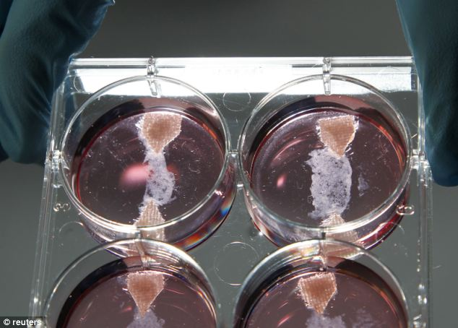
Samples of in-vitro meat, or cultured meat grown in a laboratory at the University of Maastricht
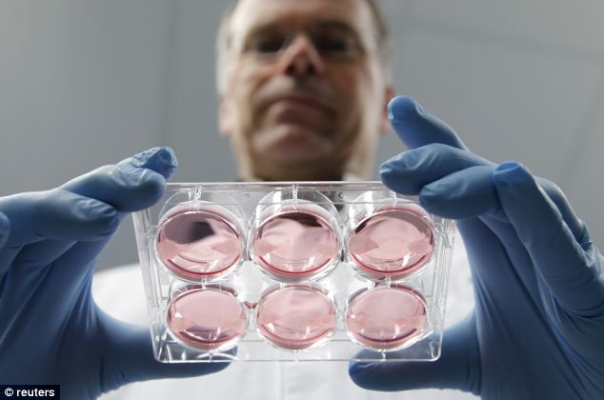

Scientists are cooking up new ways of feeding the world's ever growing hunger for meat that could save the environment and the lives of millions of animals
The hamburger, built from strands of beef muscle tissue grown in a laboratory and to be cooked and eaten at an event in London is meant to prove to the world — including potential research fund donors — that so-called in-Vitro meat, or cultured meat, is a reality.
His work is funded by the Dutch government, as well as an anonymous donation of 300,000 euros – but it remains to be seen, however, whether the pioneering development will find favour with a public that likes to think of its chops, steaks and sausages as having their roots in nature, rather than in test-tubes.
His burger consists of about 20,000 thin strips of cultured muscle tissue, the New York Times reported.

Dr. Post, who has conducted some informal taste tests, said that even without any fat, the tissue 'tastes reasonably good.'
He plans to dish it up at an event in London next month - adding only salt and pepper for flavour.
The cell-grown burger is produced with materials — including fetal calf serum, which used to grow the cells — that will eventually be replaced by materials not originating from animals, the New York Times reported.
In-vitro meat or cultured meat is an animal flesh product that has never been part of a complete, living animal, and is quite different from imitation meat or meat substitutes, which are vegetarian foods made from vegetable proteins like soy
Dr. Post has all but promised that meat will soon be grown in his lab.
Manufactured cultured meat could be sold next to animal meat for a competitive price - but experts claim this development is far into the future.
'This is still an early-stage technology,' said Neil Stephens, a social scientist at Cardiff University in Wales told the NYT.

Online Comments:

To the person who said, “what would happen to the cows, pigs and chickens”? Think please. First of all, all the animals that are in place would be killed and taken apart for your pleasure. Afterwards, it would be supply and demand. The more people don't buy, the less they will need to produce. It's more about thinking of the future animals that won't have to be born into a cruel slaughterhouses for our taste pleasure.

Disgusting, because no, there is nothing natural about this, you might as well defecate on a petri dish, culture it, then eat it.

Tell me, what would happen to the vast numbers of cows, sheep, pigs, chickens etc if we did have a substitute for them? Think the farmers would keep them as extraordinarily expensive pets? Would you pay to see them in a wildlife park? Perhaps we might just turn them loose to roam at will. And what about predation or illness striking? No veggie has ever answered me that.

Is it safe to eat? Is it tasty? Is it affordable? If the answer to all three is yes, then I will eat it.

I'm just shocked that people are even considering eating this. There is nothing natural about this, no wonder why cancer and obesity are on the rise, it's because people don't care what they put in their bodies as long as it tastes and looks like the real thing. –

You can't really blame this for cancer seeing as though it's not commercially available. "Normal" meat causes enough cancer and obesity, maybe this is a solution. If they find a cheap way to mass produce it will save a load of rainforest that would usually be destroyed for cattle and soy production. It would also be a possible food source for astronauts.

I think this may be the future. Feeding and slaughtering animals for food takes up a lot of natural resources and is becoming increasingly expensive to produce as global population expands.

