The Blood Supply - Canadian Red Cross and Canadian Blood Services
By Spencer, Nathir, Emad, Ethan

Who are the Canadian Red Cross and Canadian Blood Services?
The Canadian Red Cross is an organization that aims to improve the lives of vulnerable people across the world through government aid and the generosity of Canadians nationally. They are part of the largest humanitarian network globally. Their goal is very broad, which is why they fall under the blood donation and distribution category along with the Canadian Blood Services. The Canadian Blood Services is a charitable, not for profit, organization that collects, manages and distributes blood, and blood related goods (like plasma, and platelets) nationwide. The Canadian Blood Services was formed in 1998 to be a successor to the Canadian Red Cross that used to fulfill these roles in Canada in the past. These organizations play an important role in transporting these blood related goods nationwide, to those who are in need.

Why is blood and blood related products important?
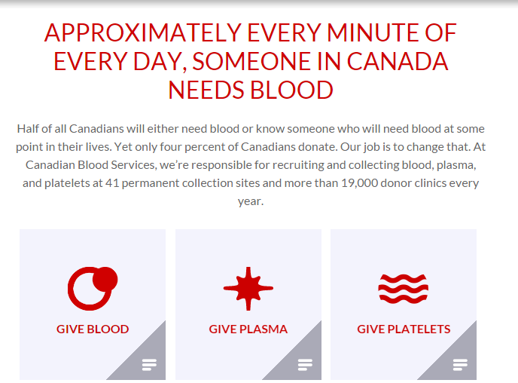
Blood products are used in a variety of different ways. Nowadays, whole blood is rarely used on its own as treatment. It is usually separated into different components; Red blood cells, platelets and plasma. These are important terms to know. The red cells of blood cells, which are used to distribute oxygen throughout the body, are used in treatments such as rheumatoid arthritis, or certain cancers. Another component of blood, platelets, is used in bone marrow failure, post-transplant and chemotherapy, as well as leukemia. Finally, plasma which is stored in two different forms, frozen, and processed are used in procedures like organ transplants, accident victims and other procedures/trauma victims that involve a large amount of blood loss. Whole blood can be used, and is generally used in blood transfusions. There is a lot more going on behind giving blood. This is why the donation of blood is essential to saving the lives of people every day.
Timeline of Important Related Events
1940 The U.S Government establishes a national blood collection program
1948 The Red Cross begins the first nationwide blood program for civilians by opening its first collection center
1972 The Red Cross calls for national blood policy, which the federal government sets up in 1974, supporting standardized practices and an end to paid donations.
1985 After dozens of Americans are infected with AIDS from blood transfusions, the first blood-screening test to detect the presence or absence of HIV antibodies: the ELISA test
1992 First National Testing Laboratory, applying standardized tests to ensure safety of Red Cross blood products

Ethic issues surrounding blood donation and blood products
Under the provisions of Section 351 of the Public Health Service Act (PHS Act) and the Federal Food Drug and Cosmetic Act (Fun fact: Blood has been treated as a ‘drug’ under the Drugs and Cosmetic Act (D and C Act)), FDA investigators conduct multiple inspections of blood establishments. However, the D and C Act isn’t all that it's cracked up to be. Failure to revamp and update the Act makes the Act lose its quality. New techniques, for example Nucleic Acid Testing (NAT) are not mentioned in the Act. Nucleic acid testing is a molecular technique for screening blood donations to reduce the risk of transfusion transmitted infections (TTIs) in the recipients, thus providing an additional layer of blood safety. Not including this technique is an issue. In a recent Malaysian study, 1388 donor samples were tested by using serology methods (Serology is the scientific study of serum and other bodily fluids) as well as NAT, scientists found 1.37% samples reactive on standard serology methods but non-reactive by NAT. These samples were confirmed to be “false reactive” on confirmatory serological tests. Not having NAT’s in the D and C Act can create ethical issues. Blood banks not using NAT’s could potentially turn away healthy donors, donors that could help someone.

Discussion Questions

- How important do you guys think these organizations are?
- Do you think the federal or provincial government should put more funding into these organizations?
- Do you think that these organizations are underappreciated?
- How would society change be if these organizations were not created?

